EXP-3: I2C-BASED HEALTH MONITORING NODE FOR PULSE AND TEMPERATURE ACQUISITION

CODE:
#include <Wire.h>

#define LM75_ADDRESS 0x48
#define PULSE_PIN 8

unsigned long pulseCount = 0;
unsigned long lastTempTime = 0;
unsigned long lastBpmTime = 0;

int previousPulseState = LOW;

float readTemperature()
{
Wire.beginTransmission(LM75_ADDRESS);
Wire.write(0x00);
Wire.endTransmission();

Wire.requestFrom(LM75_ADDRESS, 2);

if (Wire.available() >= 2)
{
byte msb = Wire.read();
byte lsb = Wire.read();

int16_t rawTemperature =
((int16_t)msb << 8) | lsb;

return rawTemperature / 256.0;
}

return -999.0;
}

void setup()
{
Serial.begin(9600);
Wire.begin();

pinMode(PULSE_PIN, INPUT);

Serial.println("I2C HEALTH MONITORING NODE");
Serial.println("---------------------------");
}

void loop()
{
unsigned long currentTime = millis();

/* Pulse counting */

int currentPulseState = digitalRead(PULSE_PIN);

if (currentPulseState == HIGH &&
previousPulseState == LOW)
{
pulseCount++;
}

previousPulseState = currentPulseState;

/* Temperature acquisition every 1 second */

if (currentTime - lastTempTime >= 1000)
{
lastTempTime = currentTime;

float temperature = readTemperature();

Serial.print("Temperature: ");

if (temperature > -100)
{
Serial.print(temperature, 1);
Serial.println(" C");
}
else
{
Serial.println("Sensor Error");
}
}

/* BPM calculation every 5 seconds */

if (currentTime - lastBpmTime >= 5000)
{
lastBpmTime = currentTime;

float bpm = (pulseCount * 60.0) / 5.0;

Serial.print("Pulse Rate: ");
Serial.print(bpm, 0);
Serial.println(" BPM");

Serial.println("---------------------------");

pulseCount = 0;
}

}

OUTPUT:

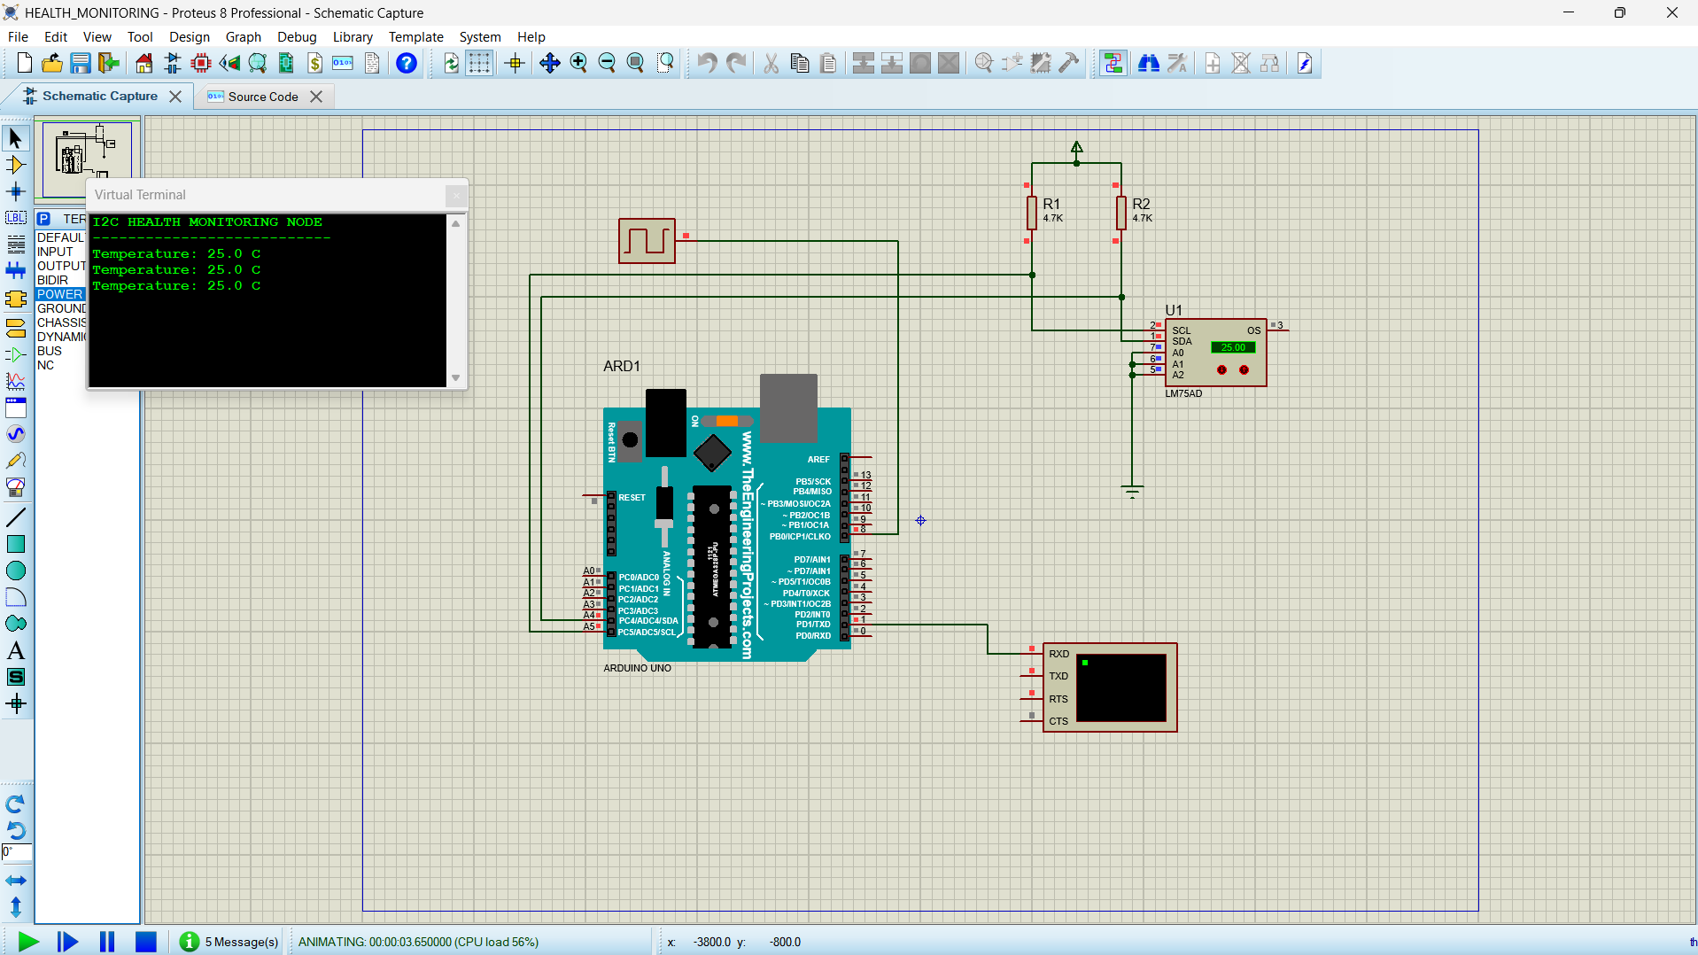

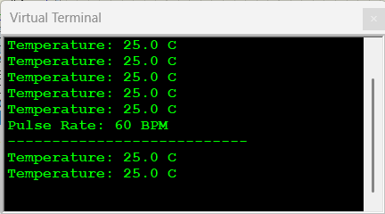

REFLECTION: I learned about I2C communication and temperature sensing using Arduino UNO. I understood how to measure pulse rate in beats per minute (BPM) and display sensor readings. This experiment improved my knowledge of embedded C programming and Proteus simulation.

